Name:

CODEBOT MISSION 1 LOG

Pre-Mission Warm-Up
What do you already know about computer science or programming?
Mission 1 – Welcome to CodeSpace
Mission 1 Objective 1
- Complete the goal for Objective 1
Mission 1 Objective 2
- Complete the goal for Objective 2. If you don’t have any code in the code editor, start a new file and type anything in the text editor to meet the goal.
Mission 1 Objective 3
Objective 3: Click on the term 🔧debugging. Write something you learned from the toolbox entry. Then close the toolbox.
Mission 1 Objective 4
- Complete the goals for Objective 4.
- The simulated scene will need to rotate at least twice to meet the second goal.
Mission 1 Your First Quiz
- Answer the two quiz questions.
- The second question has two answers.
- You must click the correct answer in order to continue.

CodeSpace Review Label the parts of CodeSpace.
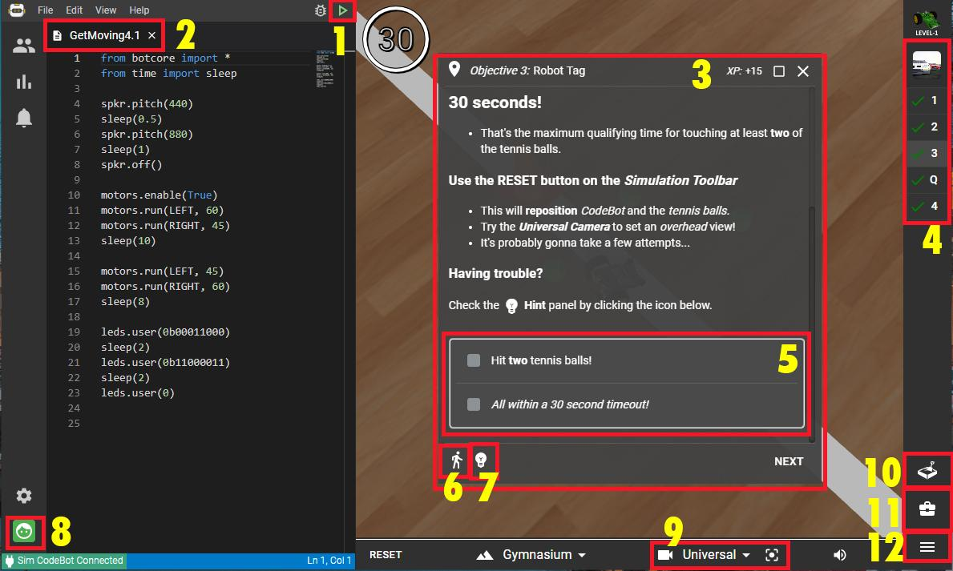
1. | 7.
2. | 8.
3. | 9.
4. | 10.
5. | 11.
6. | 12.

CodeSpace Parts:
- Camera controls
- CodeTrek
- Console panel
- Filename
- Goals
- Hints
- Log in / Log out
- Mission bar
- Objective panel
- Run program
- Sandbox
- Toolbox

Post-Mission Reflection
What are three things you learned during this mission?
What are two things you would like to learn more about?
What question do you have about computer science or programming?

